Secure Internet Application Development

CPS 499-63/592-65, Summer 2017

## **LAB 1: HTTP**

Hyper Text Transfer Protocol (HTTP)

* Access information on the World-Wide Web
* Combination of File Transfer Protocol (FTP) and SMTP
* Similar to FTP, exchanges document and uses the administrations of TCP on popular port 80
* Unlike to FTP, utilizes just a single association of TCP
* No partition control association
* Only information is exchanged between the client and the server
* Data exchange between the client and the server resembles SMTP
* HTTP messages are read and translated by the HTTP server and browser (HTTP Client)
* HTTP messages are conveyed promptly
* Commands from the customer to the server are implanted in a demand message
* Contents of the asked for record or other data are installed in a reaction message

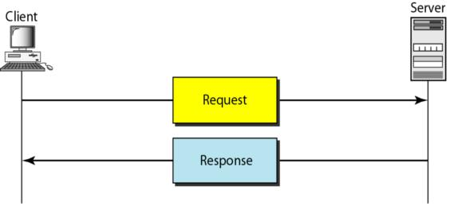

**Fig1: HTTP Transaction**

*Source: www.google.com/images*

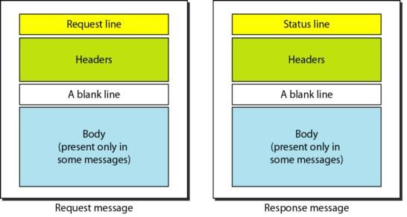

**Fig2: Request and Response messages in HTTP**

*Source: www.google.com/images*

Example:

URL 1: http://academic.udayton.edu/PhuPhung

Input: $ **telnet academic.udayton.edu 80**

Description: Telnet using telnet protocol, searches for name academic.udayton.edu and connects to it via port 80

Output:

*Trying 31.238.16.100…*

*Connected to academic2.udayton.edu.*

*Escape character is ‘^]’.*

Input: **GET /PhuPhung/ HTTP/1.0**

**Host: academic udayton.edu** (Press carriage return twice)

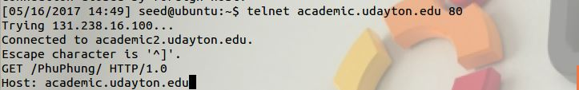

Output:

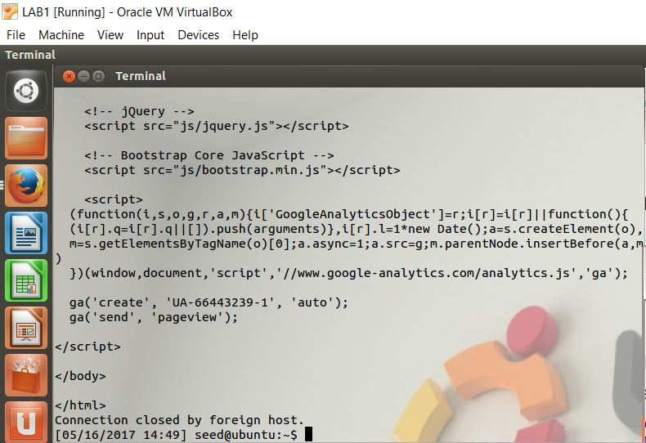

URL 2: http://gaia.cs.umass.edu/wireshark-labs/HTTP-wireshark-file1.html

Input: $ **telnet gaia.cs.umass.edu 80**

Description: Telnet using telnet protocol, searches for name academic.udayton.edu and connects to it via port 80

Output:

*Trying 128.119.245.12…*

*Connected to gaia.cs.umass.edu.*

*Escape character is ‘^]’.*

Input: **GET /wireshark-labs/HTTP-wireshark-file1.html**

Input:

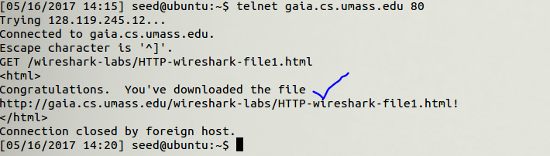

Output:

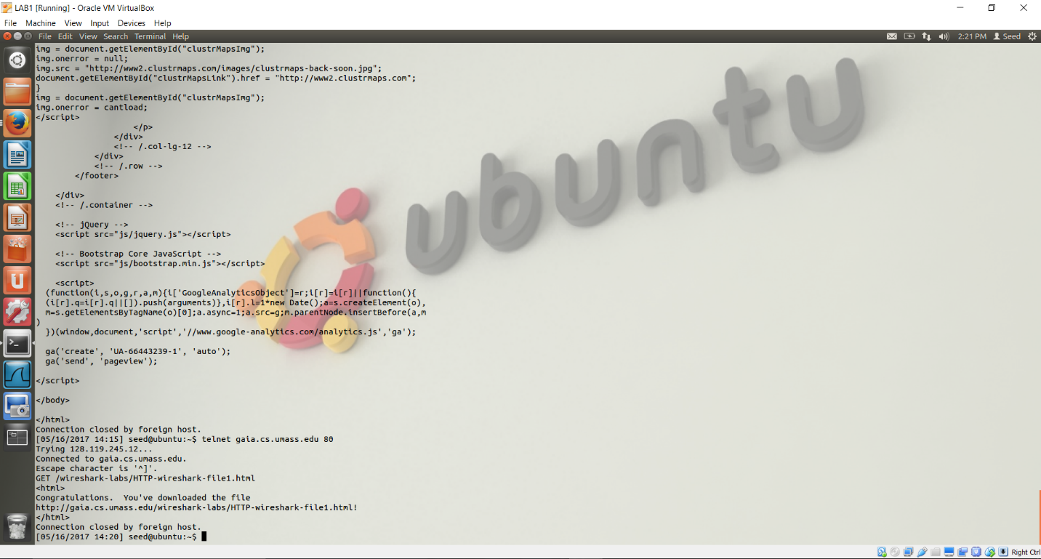

URL 3: http://www.daytondailynews.com/

Input: $ **telnet academic.udayton.edu 80**

Description: Telnet using telnet protocol, searches for name www.daytondailynews.com and connects to it via port 80

Output:

*Trying 104.106.30.145…*

*Connected to e921.g.akamaiedge.net.*

*Escape character is ‘^]’.*

Input: **GET / HTTP/1.0**

**Host: www.daytondailynews.com** (Press carriage return twice)

Input:

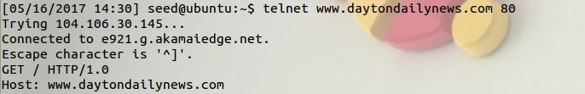

Output:

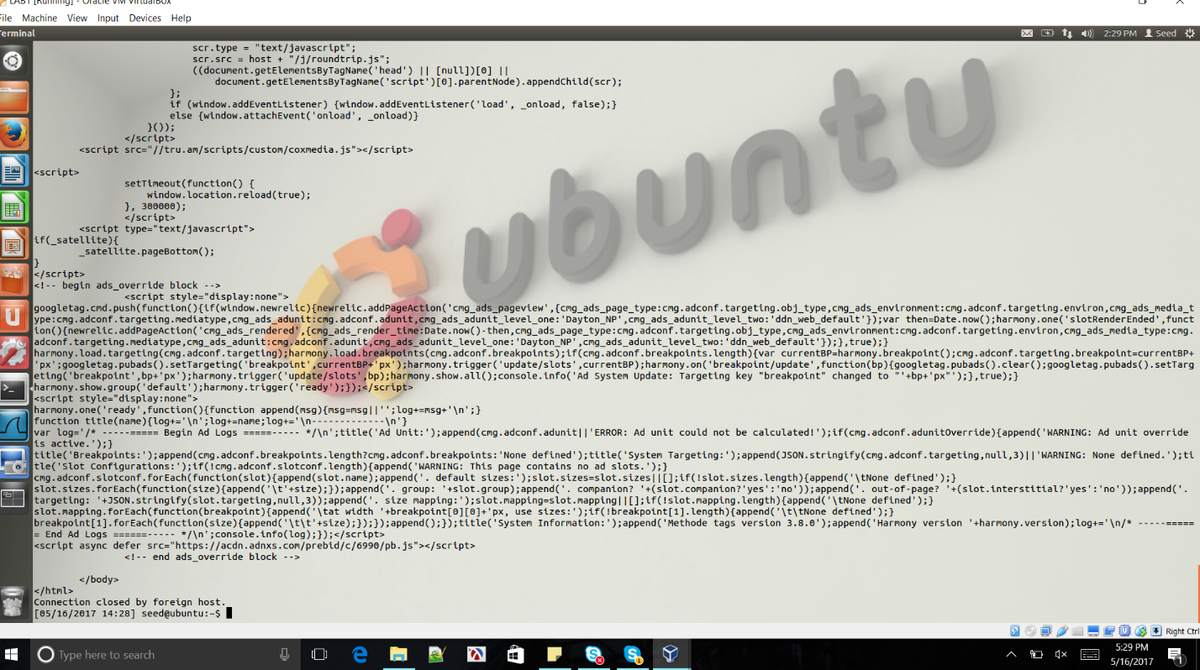

Without Host:

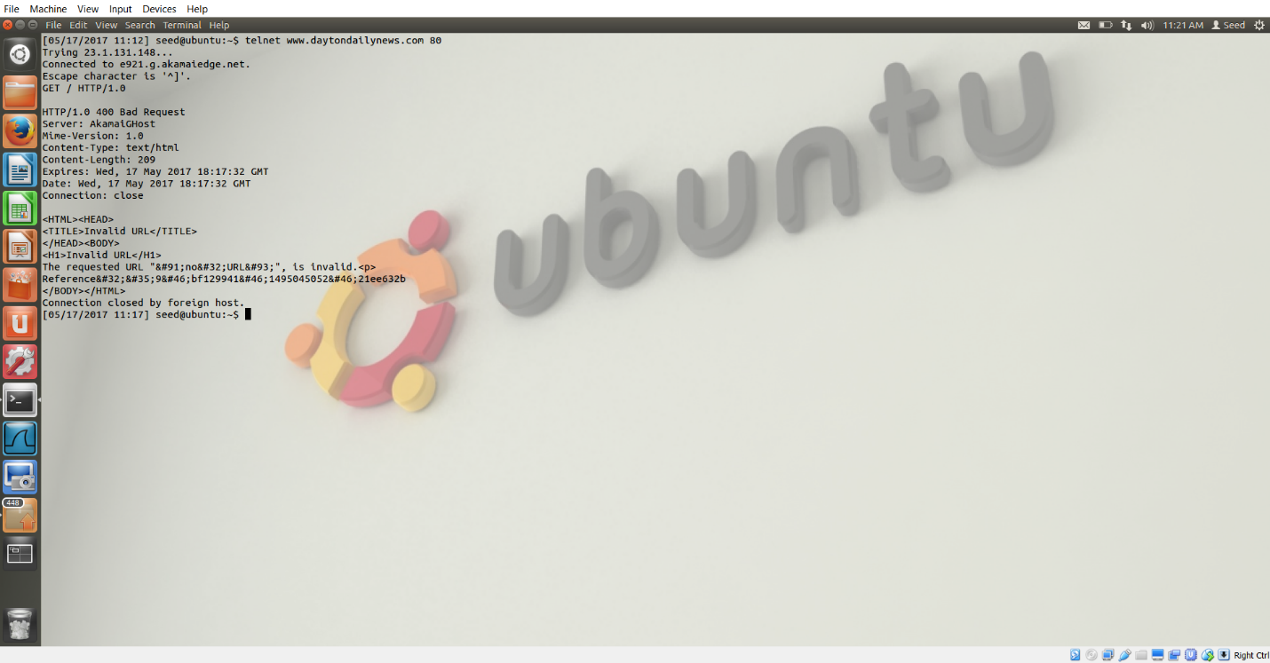

URL 4: http://isslab-udayton.github.io/

Input: $ **telnet isslab-udayton.github.io 80**

Description: Telnet using telnet protocol, searches for name www.daytondailynews.com and connects to it via port 80

Output:

*Trying 151.101.44.133…*

*Connected to github.map.fastly.net.*

*Escape character is ‘^]’.*

Input: **GET / HTTP/1.0**

**Host: isslab-udayton.github.io** (Press carriage return twice)

Input-Output Screenshots:

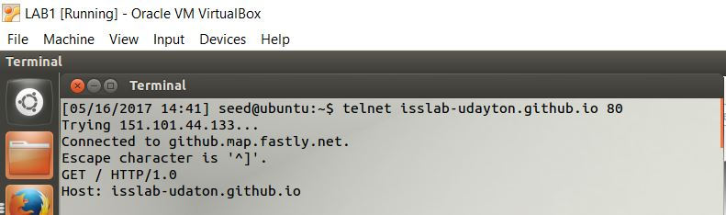

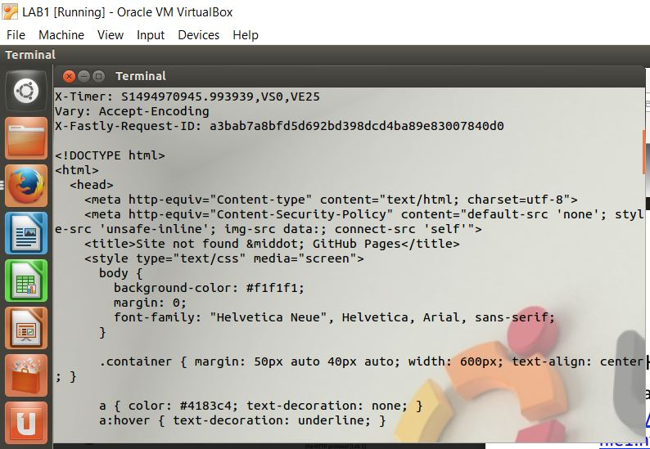

Without Host:

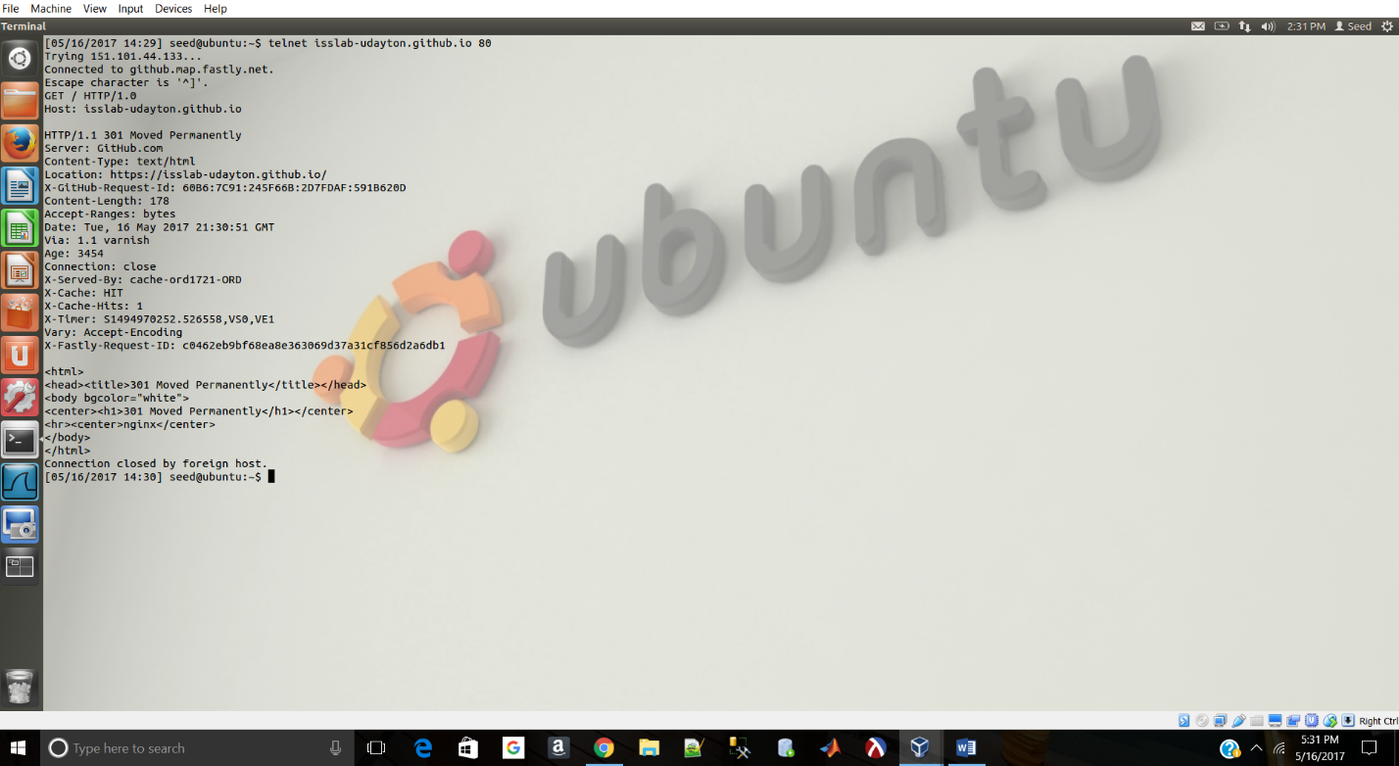

Host Name

We get an error message while trying to attempt the link without the host name.